Ghada Ahmed Abd El-Moez
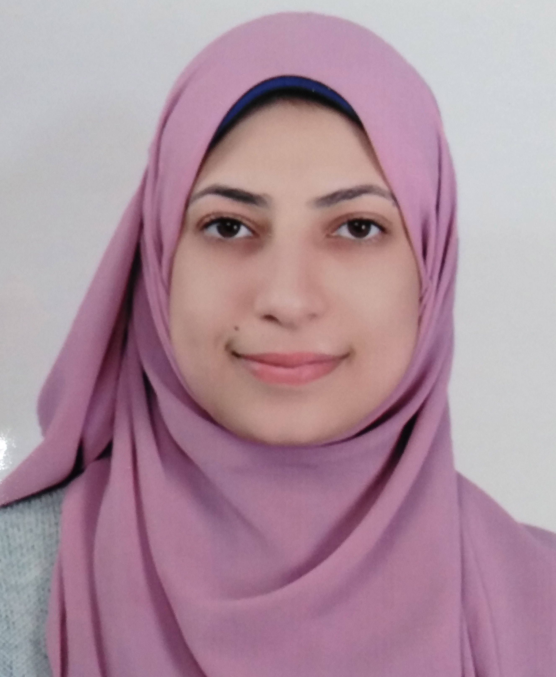
Contact data:
- Address : Assuit _ Egypt.
- Mobile number :01123803864
- E-mail : ghadaahmed5324@gmail.com
Ghada_Ahmed@pharm.aun.edu.eg

Personal information:
- Nationality : Egyptian.
- Date of birth : 12/2/1995
- Gender : Female.

Education:
Bachelor degree in Faculty of Pharmacy, Assuit University May 2018.
Graduation Grade : excellent with honour

Experience:
- At 2018 : strated a work at South Egypt Cancer Institute until 2020 .
- At 2017 : attended a training at T3A factory and AstraZenca company.
- At 2016 : attended a course at Faculy of Pharmacy about :
-Oncology,
-Commertial cosmetology,
-Refrigerator drugs,
-Therapeutic neutration,
-Drug_food interaction.
- At 2016: attended a training on lab tests at Faculty of Pharmacy and a training on protocols of chemotherapy at Tumor Institute of Assuit and tumor department in Al kasr aleiny.
- At 2015: attend a first aid course at Faculty of Medicine.
- At 2014 : attended and trained an ICDL course and attended a training at Seid factory for medicines.
Personal skills:
- Active, Self-motivated and Dynamic.
- Excellent communication skills.
- Ability to work individually and as co-operative team member.
- Ability to learn new tasks quickly.
- Ability to work well under pressure.
Language skills:
- Good command of English language (spoken - written).
- Native speaker of Arabic as the mother language.
Computer skills:
- Good in the use of Microsoft Office software
- (Windows,Word, Power point, Internet and Excel).
- Very Good user of the Internet.
- Sending and receiving e-mails by Outlook Express.
Interests:
- Reading and Surfing the net.
- Traveling and know new cultures.
- Participating in charity and voluntary.

